This is the code working as progress bar. I would use it in my donate section indicating how much money has gathered.

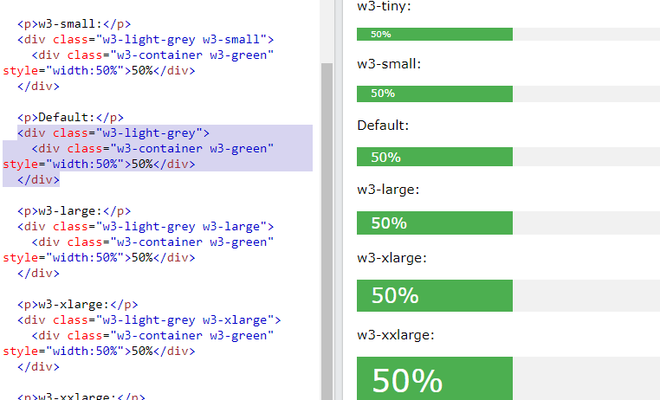

Tryit Editor v3.6. (2021). Retrieved 9 June 2021, from <https://www.w3schools.com/w3css/tryit.asp?filename=tryw3css_progressbar_size2>

I use this website to generate names for my development team.

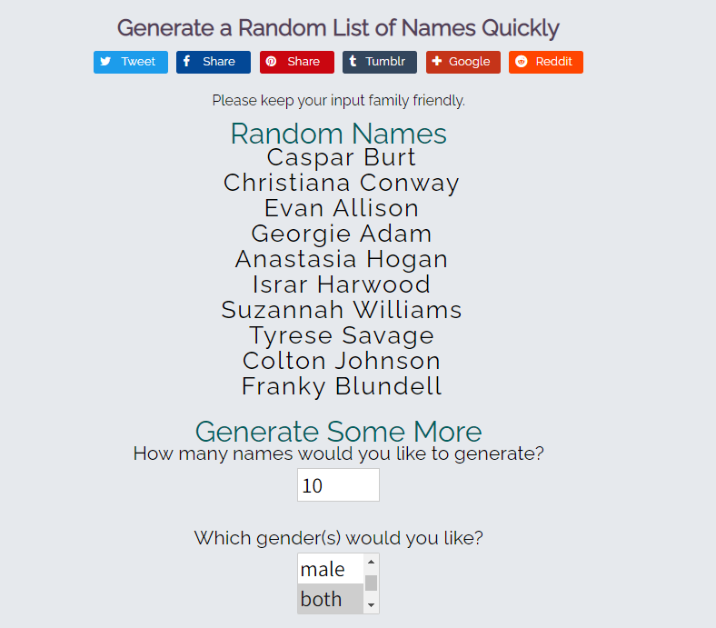

Quick Name Generator. (2021). Retrieved 9 June 2021, from <https://www.name-generator.org.uk/quick/>

There are some images I found in the Pexels wesite. I would use those images to fill up my feature section in the website.

They all follow the free licence of Pexels

So I am able to use them in my website.

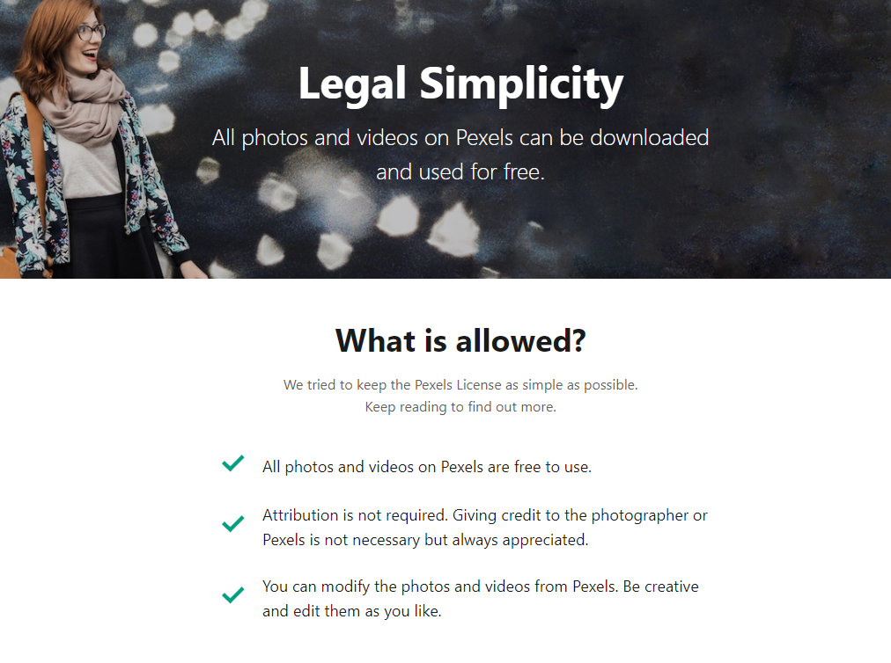

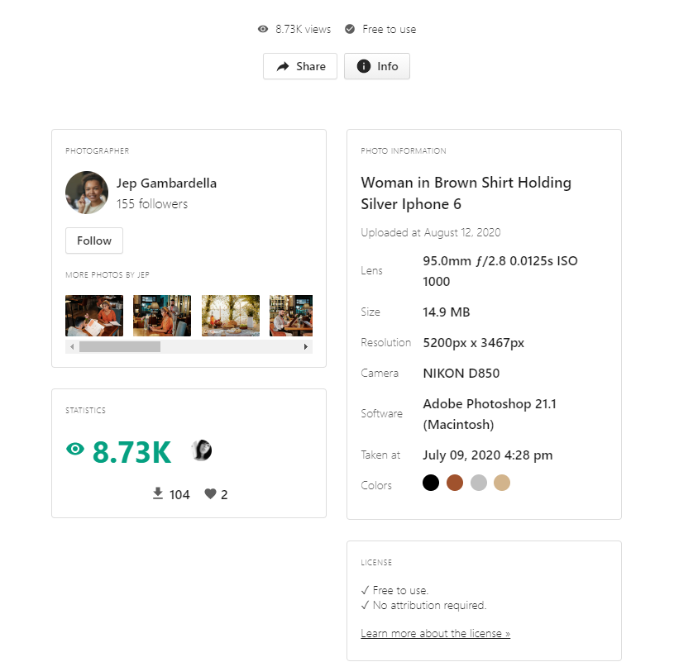

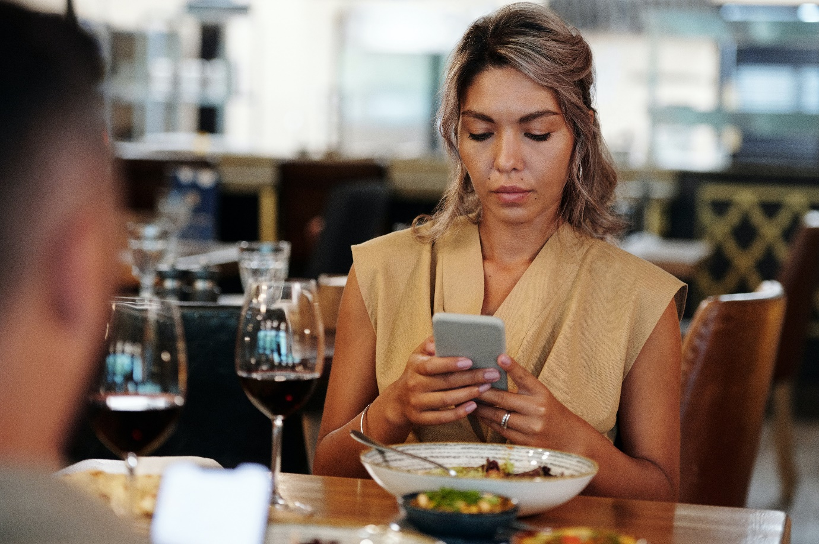

Pexels(2021). Retrieved 10 June 2021, from <https://www.pexels.com/photo/woman-in-brown-shirt-holding-silver-iphone-6-5086631/>

<https://www.pexels.com/photo/person-holding-black-iphone-7-5077054/>

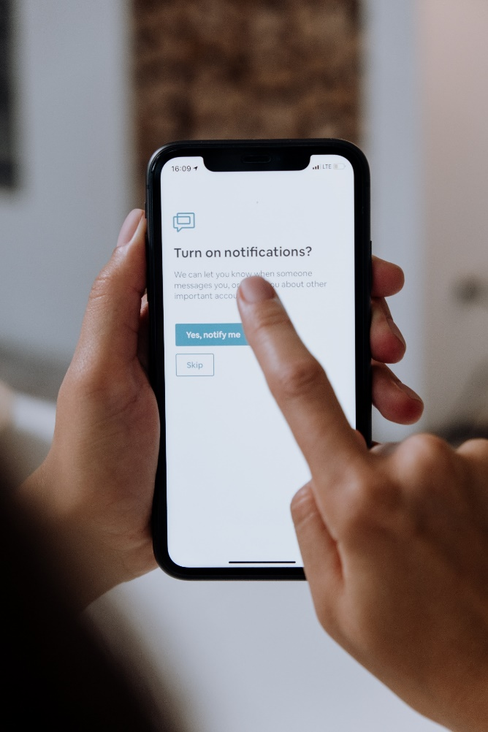

Pexels(2021). Retrieved 10 June 2021, from <https://www.pexels.com/photo/person-holding-black-iphone-7-5077054/>

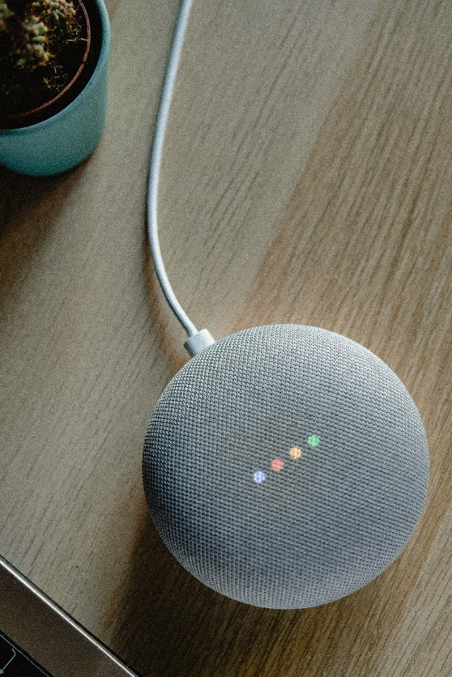

Pexels(2021). Retrieved 10 June 2021, from <https://www.pexels.com/photo/portable-speaker-on-brown-wooden-table-4893862/>

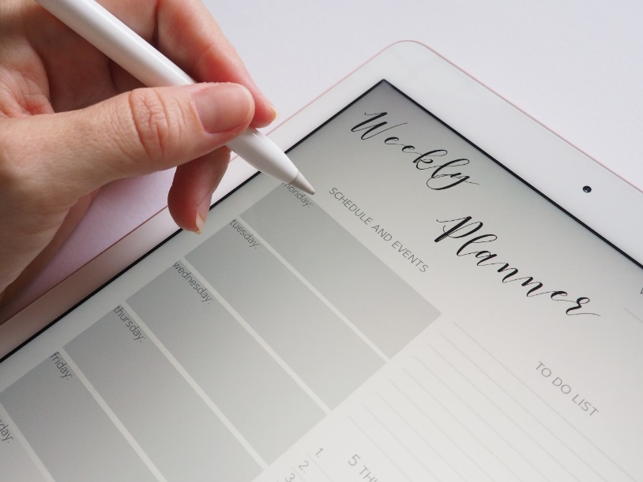

Pexels(2021). Retrieved 10 June 2021, from <https://www.pexels.com/search/schedule/>

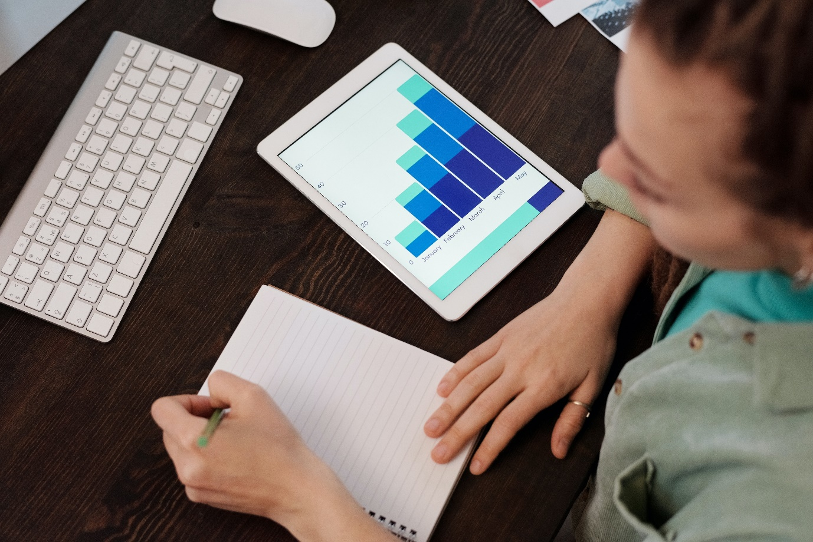

Pexels(2021). Retrieved 10 June 2021, from <https://www.pexels.com/photo/person-writing-on-the-notebook-6476574/>

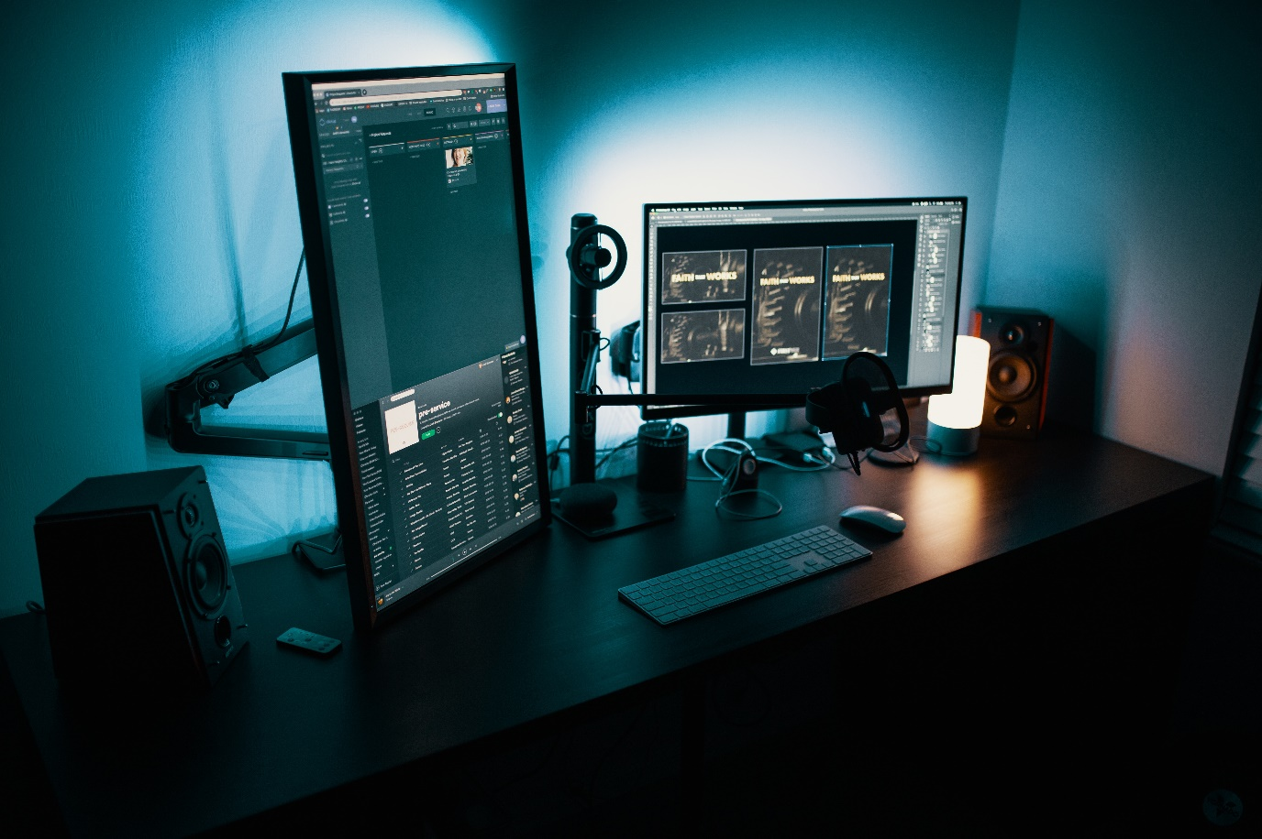

Pexels(2021). Retrieved 10 June 2021, from <https://www.pexels.com/photo/black-flat-screen-computer-monitor-1714208/>

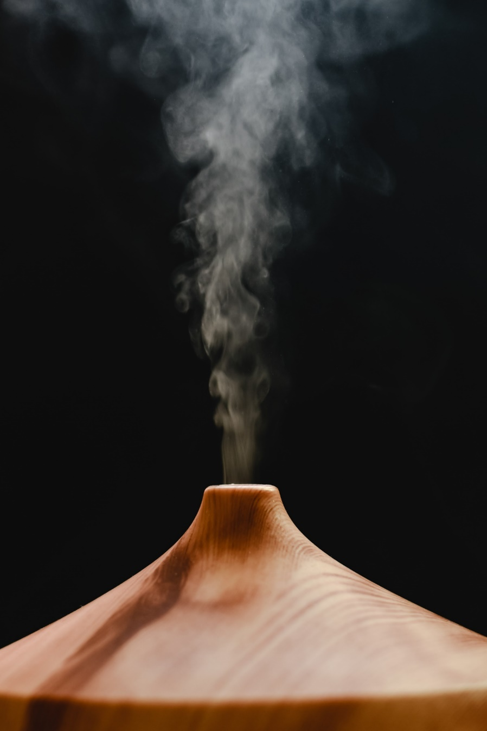

Pexels(2021). Retrieved 10 June 2021, from <https://www.pexels.com/photo/wood-landscape-people-woman-6914876/>

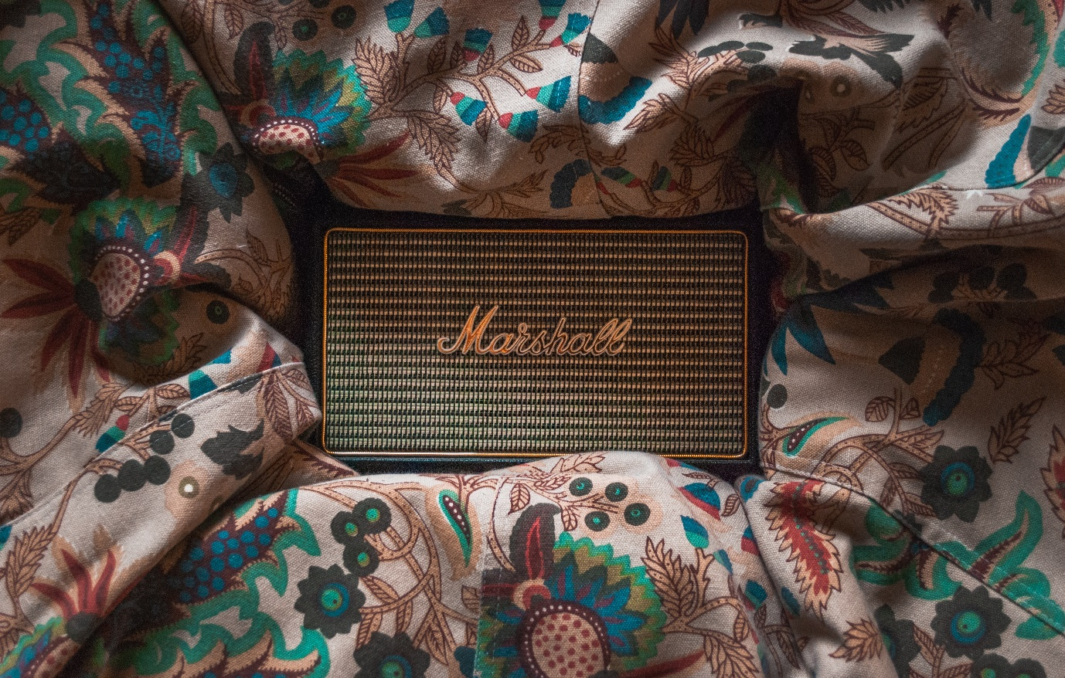

Pexels(2021). Retrieved 10 June 2021, from <https://www.pexels.com/photo/fashion-art-flowers-pattern-4430925/>

Here are four images from Pexels as well I would use them in my development team section.

They follow the same licence as above.



Pexels(2021). Retrieved 10 June 2021, from <https://www.pexels.com/search/profile%20black%20white/>

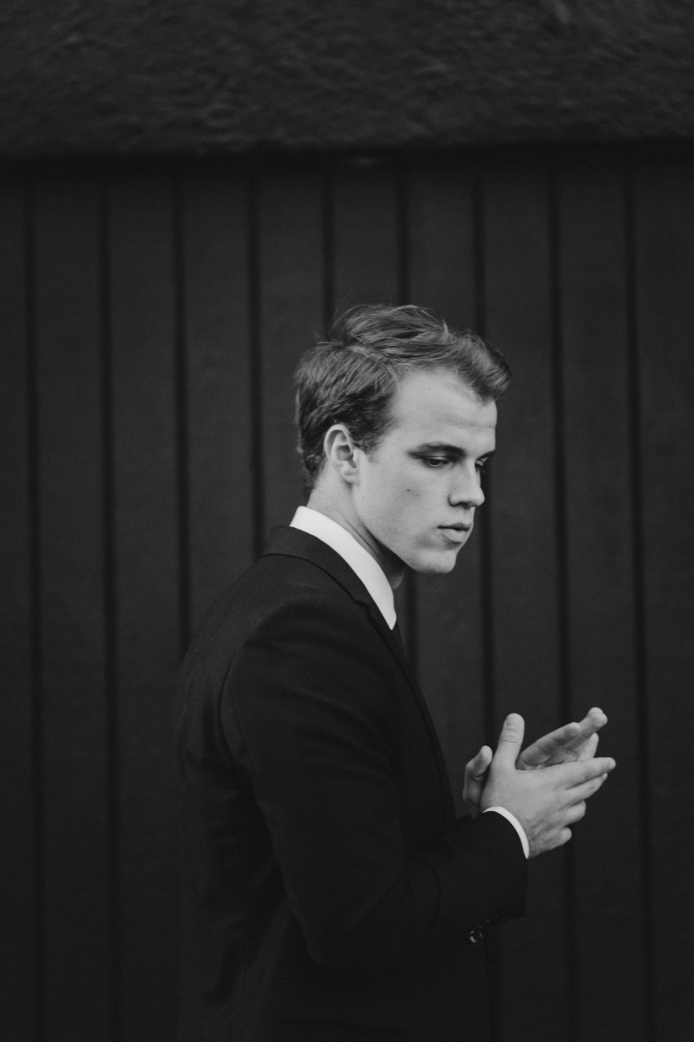

Pexels(2021). Retrieved 10 June 2021, from <https://www.pexels.com/search/profile%20black%20white/>

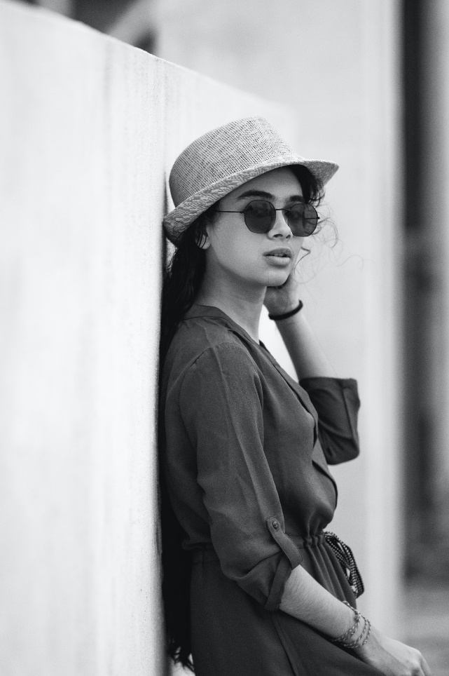

Pexels(2021). Retrieved 10 June 2021, from <https://www.pexels.com/search/profile%20black%20white/>

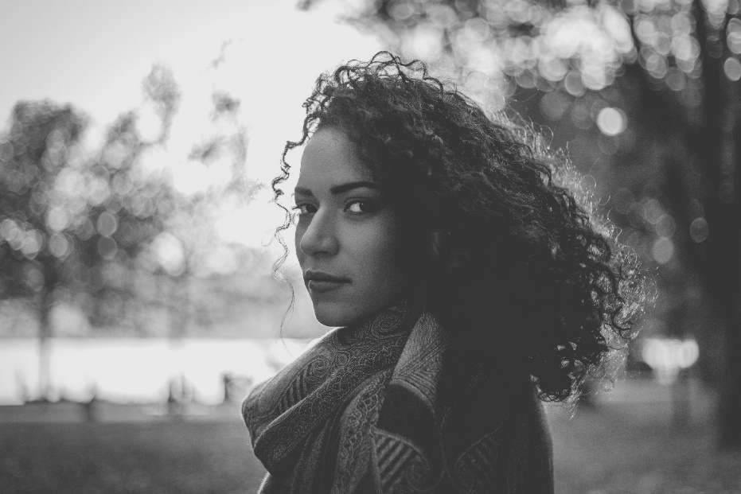

Pexels(2021). Retrieved 10 June 2021, from <https://www.pexels.com/search/profile%20black%20white/>

In my website I mainly used Rubik as the fonts downloaded from Google fonts.

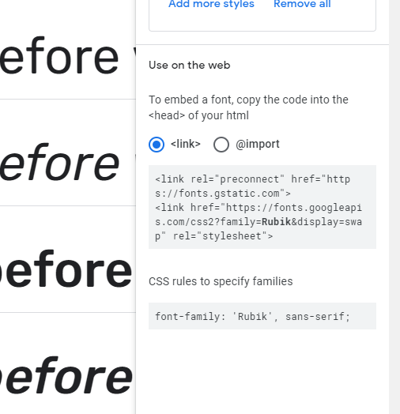

Google Fonts. (2021). Retrieved 12 June 2021, from https://fonts.google.com/specimen/Rubik?query=rubi

Here are the three buttons I found from Non project website. They are my custom player button

They follow the creative commons licence type

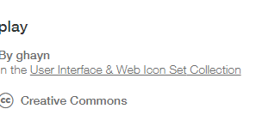

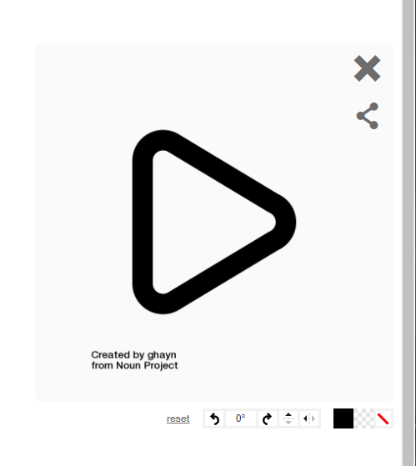

Noun Project. (2021). Retrieved 12 June 2021, from https://thenounproject.com/search/?q=play&i=2191670

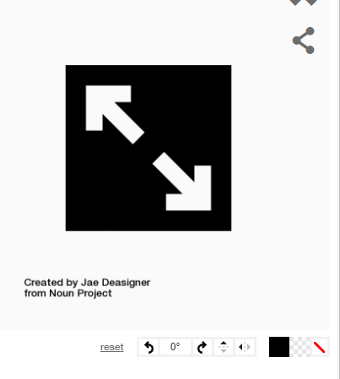

Noun Project. (2021). Retrieved 12 June 2021, from https://thenounproject.com/search/?q=fullscreen&i=3330016

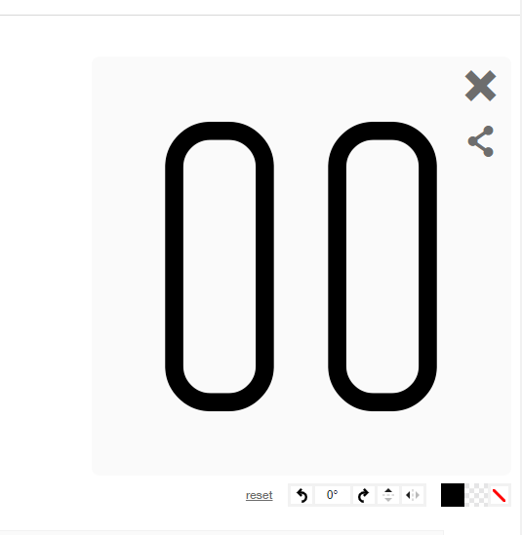

Noun Project. (2021). Retrieved 12 June 2021, from https://thenounproject.com/search/?q=pause&i=3646359